Configuration des groupes de sécurité

Creating a Load Balancer Security Group

When our load balancer was provisioned it was setup with the default security group in our VPC. To allow access to the load balancer via the public DNS, we will need to create and attach a security group to allow inbound traffic on port 80 from the internet.
As a best practice, we will also create an outbound rule that restricts outgoing traffic from the load balancer to only be sent to hosts using the Auto Scaling Security Group.
Accédez à l’icône Console de service EC2 . On the EC2 page under the "Network & Security" heading in the left-hand menu select Security Groups. You should see other security groups, including the security group for your web server named "[Your Initials]-EC2-Web-Host - Website Security Group". Now select the Create security group button.

Basic details:

a. Security group name: [Your Initials]-SG-Load-Balancer

b. Description: [Your Initials]-SG-Load-Balancer

c. VPC: Select your VPC (Most likely the Default VPC)

Inbound rules:

a. Click on the Add rule button

b. Type: HTTP

c. Source: Custom: - You can find you local IP using this site: [Input your public IP address followed by a /32]AWS Check IP

Problèmes de propriété intellectuelle locale
If there is an issue obtaining your local IP address due to your machines security setting or if it changes every time you refresh the "AWS Check IP" site then you will need to use 0.0.0.0/0 instead.

Outbound rules:

a. Change the rule with the "Type" of All traffic to HTTP.

b. Under "Destination" select Custom and in the field select your [Your Initials]-Auto Scaling SG as the "Destination". Hint: Scroll down the list to see the avaialble security groups.

c. You security group configuration should look similar to the image below. Select Create security group when finished.

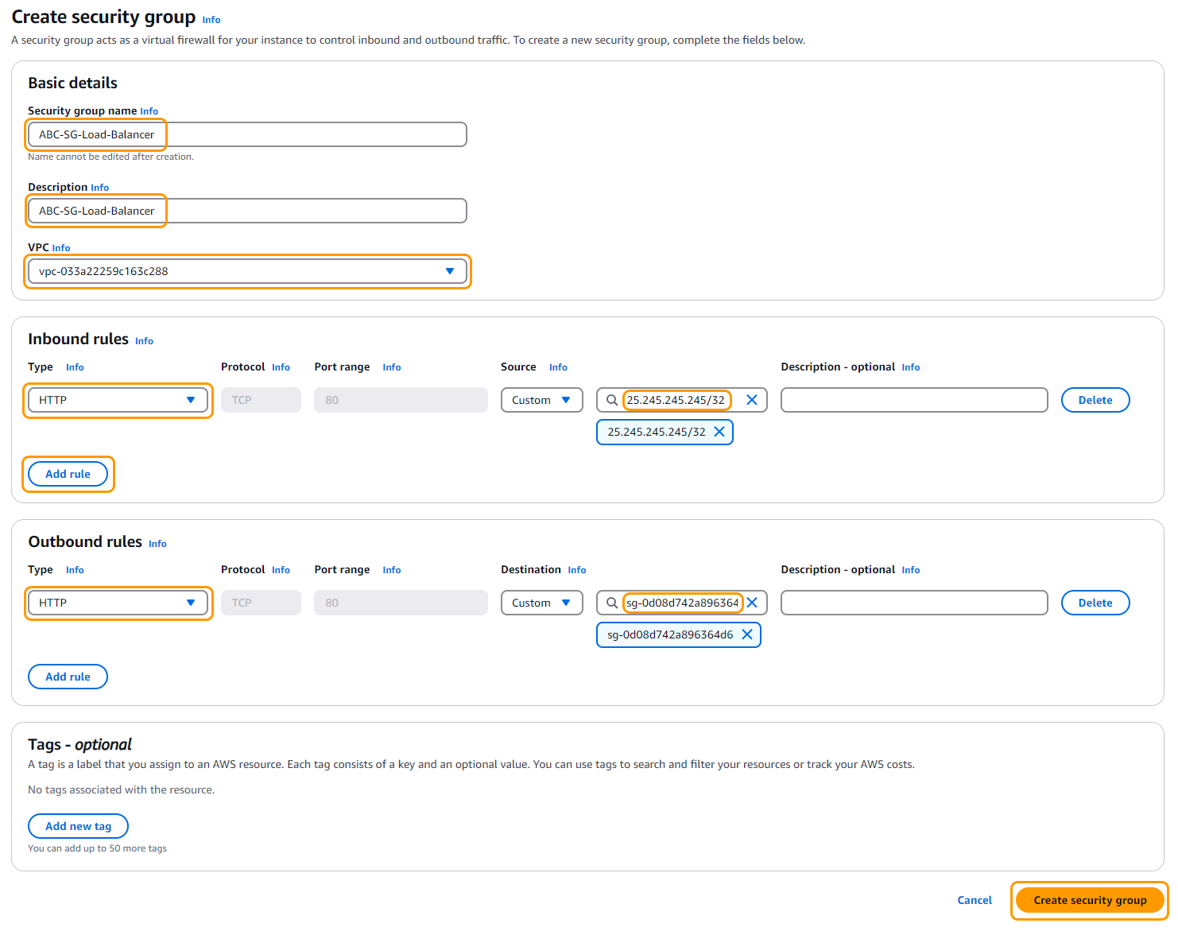

Attach your new Load Balancer Security group to your Load Balancer:

a. On the EC2 service page left side menu find "Load Balancing" and select Load Balancers. Select the load balancer you created. Make sure the State is "Active".

b. On the load balancer "Details" page select the Security tab and then select the Edit button.

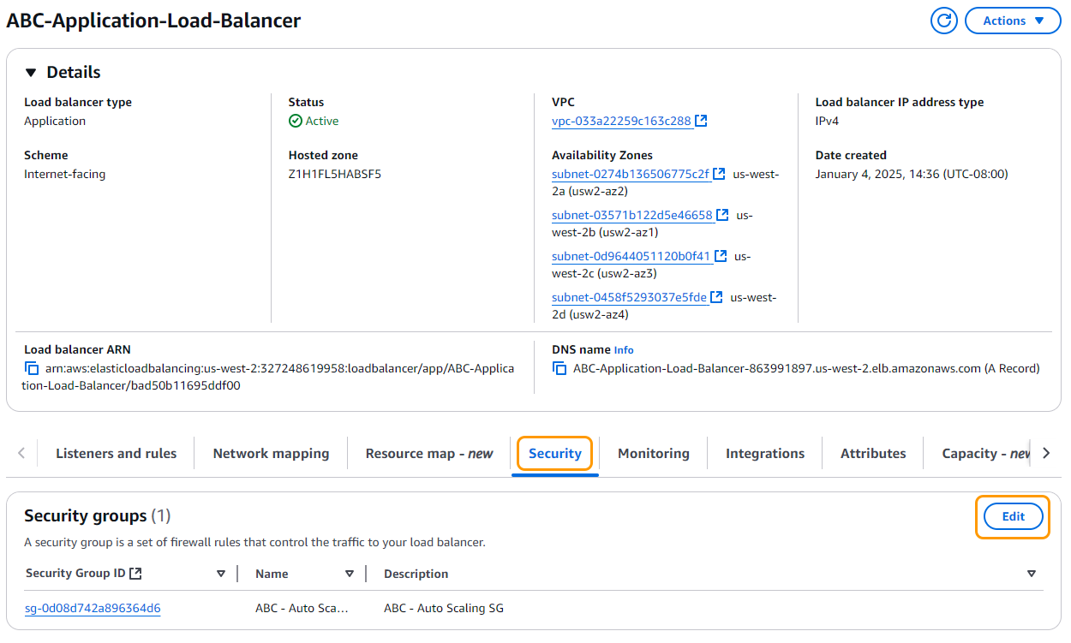

c. Remove the security group named [Your Initials] - Auto Scaling SG and select the [Your Initials]-SG-Load-Balancer from the "Security groups" dropdown.

d. Select the Save changes button when you are finished.

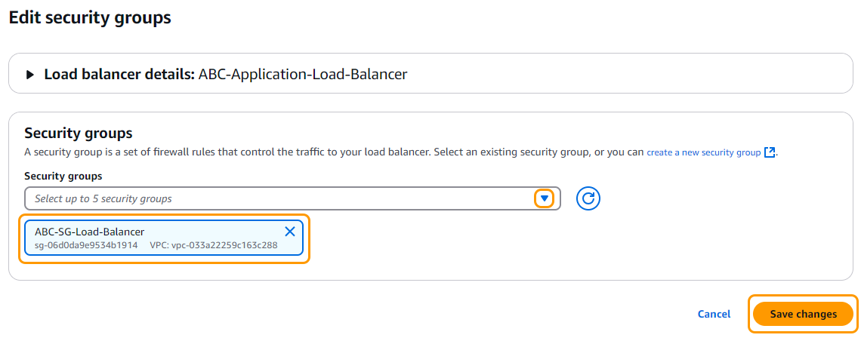
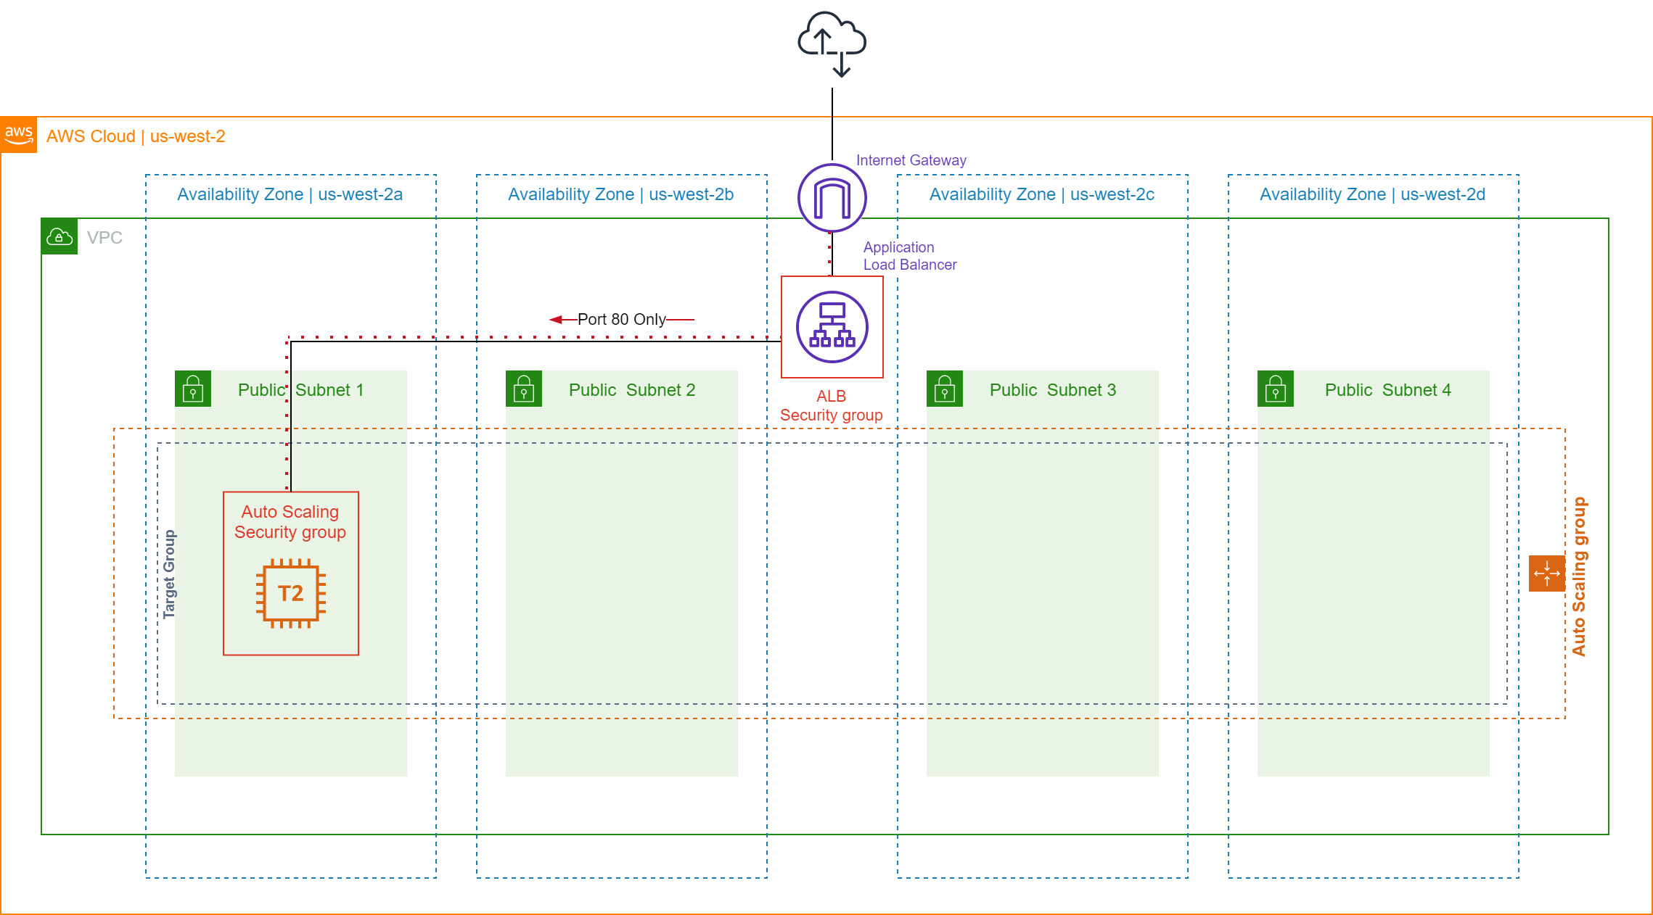

Task 4: Add Inbound Rule to the Auto Scaling Security Group

We will need to setup a rule to only allow traffic from the new Load Balancer Security Group to the Auto Scaling Security Group. This will be one of the layers of protection that will prevent our webhosts from being directly accessed from the internet.

a. On the EC2 service page left side menu under "Network & Security" select Security Groups.

b. Select your Auto Scaling Security Group: [Your Initials] - Auto Scaling SG

c. Select the Inbound Rules tab and click on the Edit inbound rules button and then the Add rule button.

d. From the "Type" drop down select HTTP. Under "Source" select Custom and in the field specify your [Your Initials]-SG-Load-Balancer as the "Source".

Your rule should now look similar to the image below.
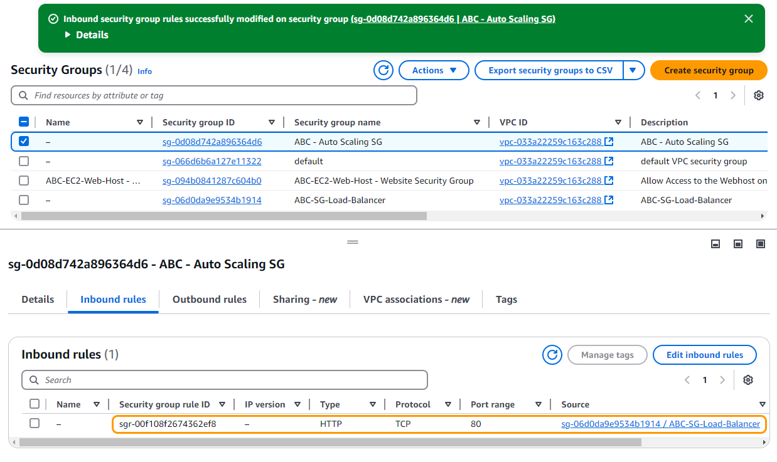
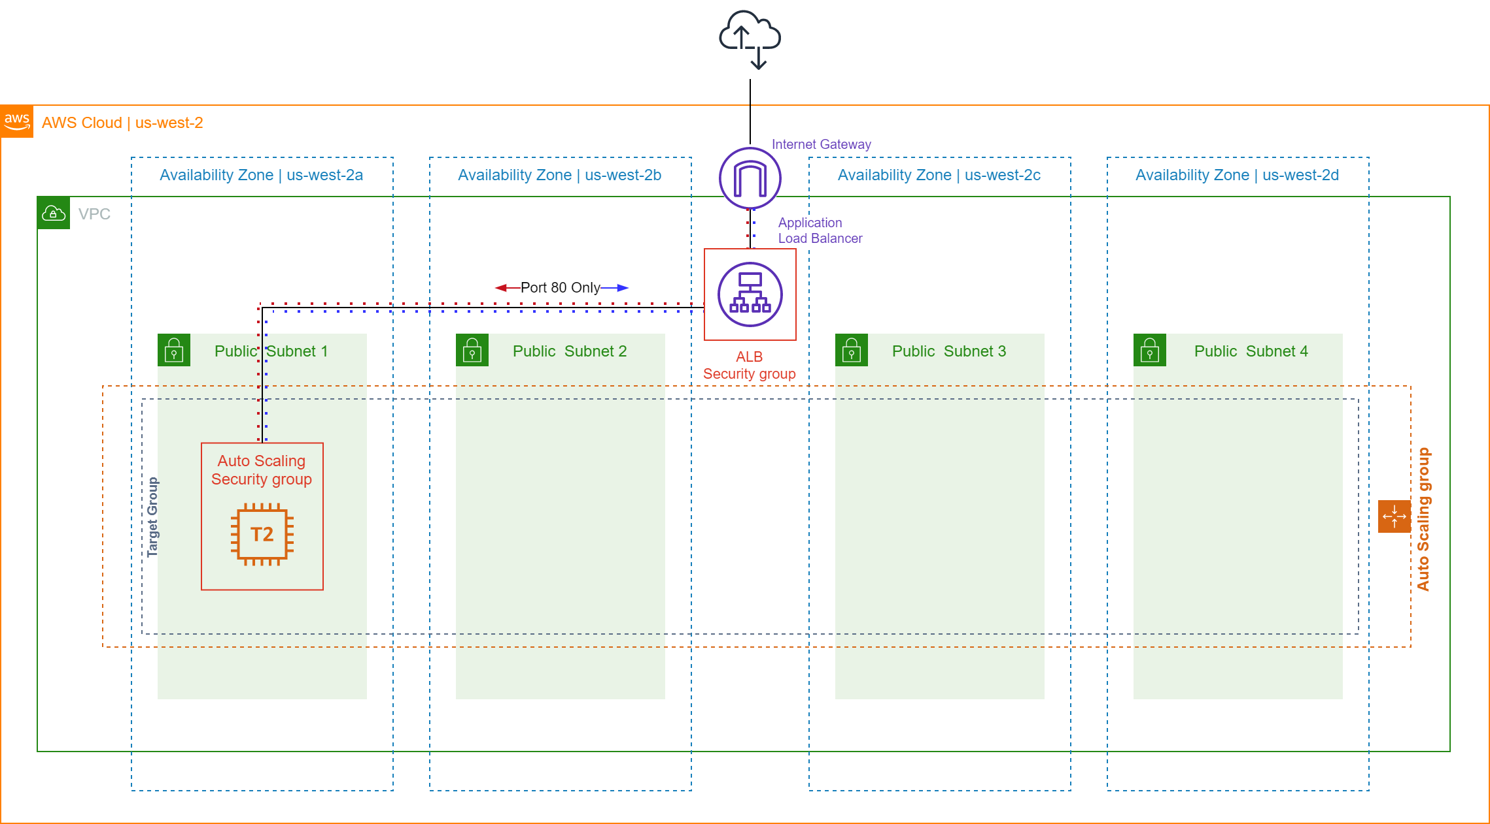

We will now test to make sure your load balancer is working. There is currently only one instance (or target) running in the auto scaling group, but you should be able to access the website.

Return to your the load balancers page by selecting Load Balancers from the left hand menu. Under the "Description" tab copy the DNS name and paste it into a web browser. You should now see the website being loaded from your auto scaling group. Leave this page open, you will need it in the next step.

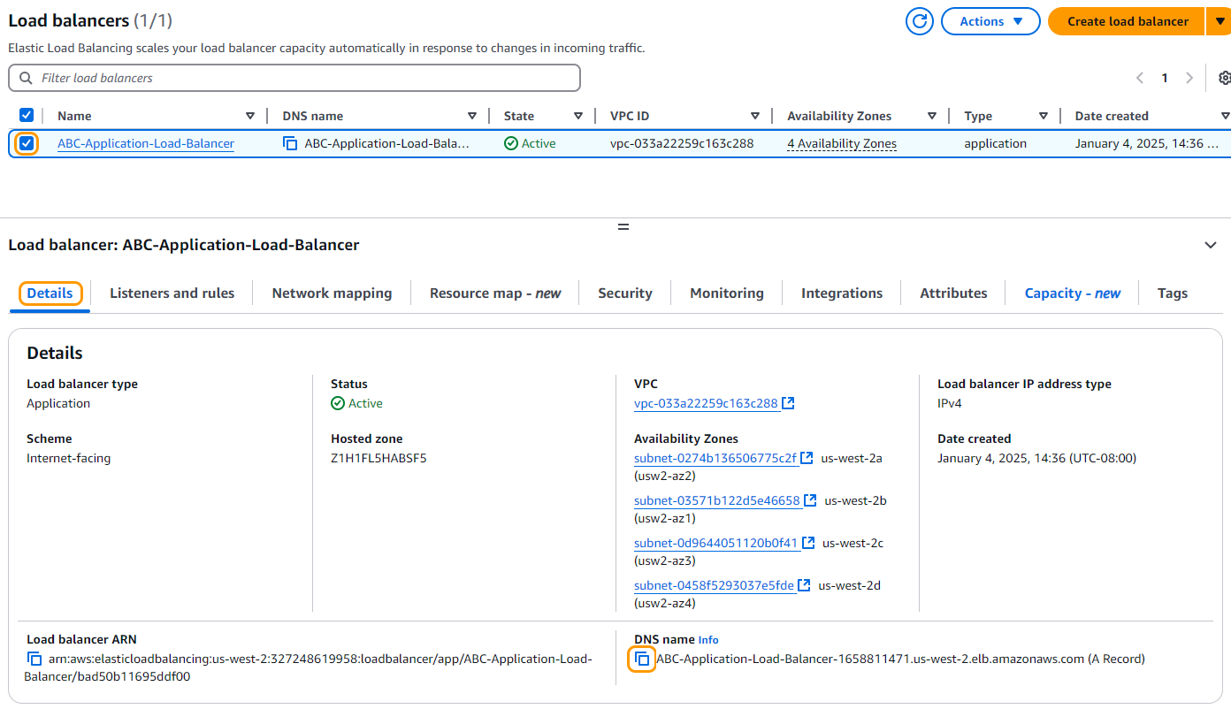
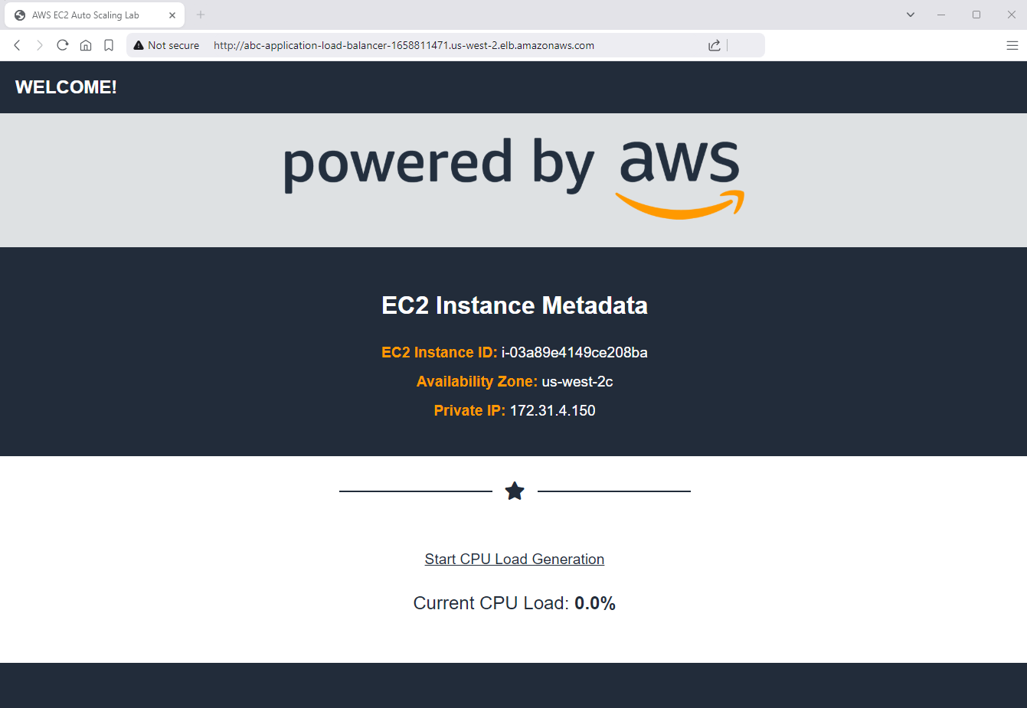

Vous êtes maintenant prêt à passer à l’étape suivante

